FOUNDATION FOR VIRTUAL AND AUGMENTED REALITY SYSTEMS
Lecture14
Lec 14: VR Hardware
Hello and welcome to the NPTEL MOOCs course on Foundations for Virtual and Augmented Reality Systems. We are currently in lecture number 7 where we are discussing VR hardware. We will continue our discussion on VR hardware in this part of the lecture. So, previously we talked about a systemic view of the VR hardware, namely different components and their relationships.
We also talked about broad categories of VR hardware, namely the input, computer, and output. Then we discussed hand-based input and we started our discussion on non-hand input. We are going to continue our discussion on non-hand input, and also we are going to talk about the processor and the output part in this lecture. So, under non-hand input we have earlier seen two categories: head input and eye-tracking-based input. There are other non-hand input methods and input devices as well; one such category is full-body tracking.
So here the devices are there to track more than just the head and hands. So earlier we tracked some parts of the body: head, hands, and eyes. In full-body tracking, we track more than that. It adds to the illusion of self-embodiment as well as social presence. So since we are tracking the full body,
The input tracks the full body movement. So, the output that can be generated based on that input can give the user a feeling of self-embodiment in the virtual world as well as social presence in the virtual world because the user gets to see a fuller representation of himself or herself. Now, there can be multiple approaches to get the input from the full body.
Broadly, there are two such approaches: one is using a motion capture suit, in short it is called MOCAP. Now, typically such suits come with various sensors within the suit. An example is shown here in this accompanying figure. This is the Perception Neuron suit. It contains a network of straps
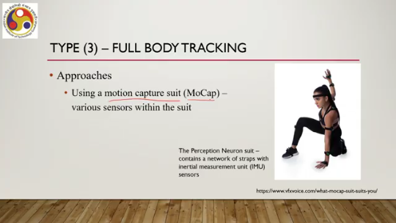
with IMU or inertial measurement unit sensors. These are the straps, as you can see here, worn at different parts of the body: leg, hand, arms, even head everywhere you can see, and when the body movement happens, these sensors capture and transmit raw movement data which then are combined and converted to full body position and movement. Another approach is using camera-based tracking; one such possible setup is shown here in this entire figure, as you can see there are multiple cameras: camera number one, 2, 3, 4, 5, 6, 7, 8.
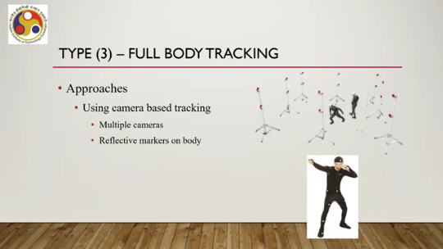
So, these are surrounding cameras. In between the cameras, one actor is there. The actor typically wears a suit with some fiducial markers. As you can see here, the cameras can detect the movement of the markers and based on that can infer the overall body movement of the character.
So, typically reflective markers are used and there are multiple cameras. An example of such a system is OptiTrack or even Microsoft Kinect can be considered to be an example of such camera based full body tracking system. So, there are broadly two approaches for full body tracking. Mocap and camera based tracking. Then category 4 refers to voice or speech or sound tracking.
So, through this type of input devices, we can capture voice, speech, and non speech sound as input for interaction in the virtual world. For that, what we need to use, what are the devices, input devices. Microphones, simple microphones or microphone arrays that is a set of microphones to capture sound in a 360 degree environment. So, those four categories are basically non hand input techniques namely the head tracking, eye tracking, full body tracking and sound based tracking. So, we have
covered the input part, hand-based and non-hand-based, let us shift our focus to the processing part, that is the computer. Computers, in our context, are devices that process the data that are coming from the input sensors, and then based on that processing, it activates or actuates the output devices now. The processing elements or computers are selected according to the requirement. For example, depending on the application or user or input-output devices, availability of input-output devices or the level of immersion required, we can choose the corresponding processing element. Sometimes it needs to be very high configuration, sometimes it can be regular configuration.
So, we can have a standard PC as a processing element or a computer in our VR system setup, or we can go for high-end workstations having high-quality GPU as part of the, processing element of our VR system, or we can have a distributed computer system interconnected through a high-speed communication network as part of our processing component. Or even we can use our smartphone for doing the processing. So, the range of processing elements can be used, which depends on the kind of application we are trying to develop, the kind of users we are targeting,
the kind of input and output devices we are assuming, and the kind of immersive experience we plan to provide. When we talk of processing element or the computer, the major three components that come into mind are the GPU, CPU and RAM. We all know the terms. So, when we talk of GPU or graphics processor unit, multi-GPU enabled systems are typically used for building VR applications and for rendering also we prefer to have good quality GPU enabled graphics card.
GPU stands for graphics processing units. For those who may not be aware, these are typically used to speed up the rendering process because of their inherent parallel processing abilities and the inherent parallelism in the rendering process. So, later on we will take up this issue in more detail in another part of the course where we will talk about computer graphics, the rendering process and how GPUs are suitable for such a process.
For the time being, it is sufficient to know that GPUs are very useful in rendering complex graphics and complex scenes that are typically part of realistic VR experiences. So, GPU-enabled environments are preferable. Even modern-day CPUs are also quite powerful. However, CPUs have many other tasks to do. So, if we solely depend on CPU-based systems where GPU support is minimal, then there can be performance issues.
However, multicore processors can greatly increase computational capacity and can support in a better way as compared to non-multicore or unicore processors, but nowadays, of course, by default all processors are multicore. So, they are quite powerful. However, GPU support is preferable. On the RAM part, each XR engine
has its own minimum RAM requirement. What is an XR engine? We will cover this in a subsequent lecture. It is basically a middleware that is required to support and render, to develop VR experiences as well as render the experience. Now, each such engine has its own requirements.
Typically, at least 8 GB of RAM is preferable to have in your VR system hardware part. to have a good user experience. So, that is in brief about the processing elements; just covered the basic ideas. Then let us move to the output devices. What kind of output devices are typically used to render VR experience?
There can be several categories of output devices starting with the visual display. Then we have audio output, then we have haptics, then motion platforms and treadmills, and some other sensory outputs that means the outputs are meant to stimulate other sensory organs such as taste and smell sensory organs, namely the tongue and nose. But these are quite premature systems not widely used or widely available. or even popular.
So, we will skip any discussion on these types of systems. They are still confined mostly to highly specialized environments or research domains. So, we will mostly focus on visual displays, audio output, haptics, and motion platforms and treadmills. Let us start with the visual displays. Now when you talk of visual displays, these are essentially displays meant to stimulate our visual sense, that is, our eyes.
So, there can be three broad types of visual displays. The first category is head-mounted displays or HMDs, which are wearable and mobile. Then we have world-fixed displays which are not wearable; they are stationary. And finally, regular displays, which are mobile or can be stationary. So, we have HMDs, world-fixed displays, and regular displays.
Let us talk about HMDs. So, these are a common metaphor for VR. Whenever we say or use the term VR, essentially we refer to HMDs. Or it comes to our mind that somebody is wearing such a headset and experiencing something. So, a very common metaphor.
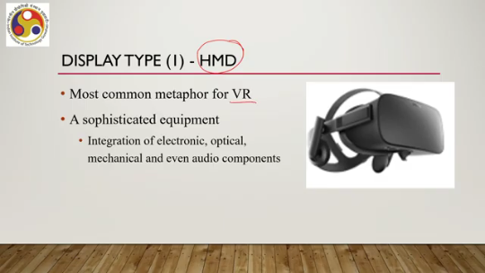
Earlier we have seen that HMDs can be used as input to track head motion, but their primary use is as a display device. So, it is a sophisticated piece of equipment. It integrates electronic, optical, mechanical, and even audio components within this package. It places images directly in front of the user's eyes using either one or two small screens. So, when it is using one screen, that is for monoscopic viewing; when it is using two screens, that is for stereoscopic viewing.
So, of course, HMDs with stereoscopic viewing are more common as compared to HMDs with monoscopic viewing. Now, HMDs themselves can further be categorized. There are three categories of HMDs. One is non-see-through, one is optical see-through, and the third one is video see-through. Non-see-through types of HMDs are typically used in VR.
Optical see-through HMDs are typically used in AR. Whereas the third category, which is video see-through, is typically used in augmented virtuality. That is, we are experiencing an artificial or virtual environment within which some real-world images or videos are appearing on a real-time basis. So that is augmented virtuality. Recollect our discussion on it in our earlier lectures, the first and second lectures.
Now, we have video see-through HMDs that support augmented virtuality. So, that is about HMDs. Then we have a second category of display that is World Fixed Display. It renders graphics onto surfaces that do not move with the head. So, we have
a display surface or display screen that is fixed and does not move with the head. The displays range from standard monitors to displays that completely surround the user, which is typically called a cave. One early example of such a world-fixed display used for VR is the fish tank display. developed way back in 1993. It is described as a stereo image of a 3D scene viewed on a monitor; a fixed monitor cannot be moved using a perspective projection coupled to the head position of the observer.
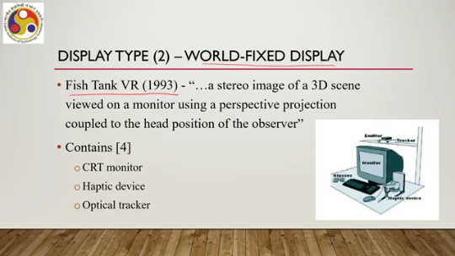
The setup is shown here. There is a tracker which tracks the head position. This is the monitor which is fixed. It cannot move around. And then there are haptic devices that are the input part.
So, let us keep that part. So, when the user moves the head, the content on the monitor changes; it shows a perspective view of the content which is typically what we get to see in the real world, and the head position is tracked using the tracker. So, with the movement of the head, the view changes and the user gets the sense of being there.
It contains a CRT monitor, a haptic device, and an optical tracker; the latter two are the input part, whereas the monitor is the output part, which is the world-fixed display. A more recent world-fixed display example is the surround screen. Displays which are typically known as cave systems. Typically they have three to six large screens, putting the user in a room for visual immersion, so the user is surrounded by screens. Such systems are usually driven by a single or group of powerful graphics engines and require elaborate tracking, tracking of the user's movements.
So that is another example of a void fixed display; here the display is not moving, rather the user can move within a physical space. The third and final category are the regular displays. They refer to the regular tabs or smartphones that we have. They are mobile of course, nothing specialized is there. Typically, they are relevant for non-immersive VR and mostly used for augmented reality or AR.
So that is about the most prevalent form of display, which is the head mounted display. There are other output devices as well. Let us talk about those. Audio output is another part of the output devices that are typically used in a VR setup. We can have specialized audio that can provide a sense of where sounds are coming from in 3D space.
Speakers can be fixed in space or move with the head to get that specialized feeling. Headphones are preferred for a fully immersive system where, with the movement, the sound source can change with the head movement and accordingly we can get the specialized feeling. Then we have haptic rendering systems, or systems that activate our touch sensation. Now, haptics are outputs exploring our touch perception, and it can be categorized in different ways.
The types of haptic outputs that we can use can be categorized in different ways. We can have passive versus active devices. We can have tactile versus proprioceptive devices. We can have self-grounded versus world-grounded devices. So, passive devices are static physical objects, whereas active devices are physical feedback controlled by the computer.
Tactile are touch sensations obtained through the skin. So, our skin gets activated, whereas proprioceptive forces are activated. Forces are those that activate our joints or muscles. Self-grounded means the devices are on the body, whereas world-grounded means they are attached to the real world; they cannot be moved around. So, when we talk of passive haptics, we are referring to real-world physical objects that match the shape of the virtual objects.
So, when we touch those real-world objects, we get a feel of interacting with the virtual objects. But those real-world physical objects are not controlled by the computer. Whereas in the case of active haptics, we have objects, physical objects that are controlled by computers which give us a sense of touch when we are dealing with virtual objects. So these are the more common forms of haptics used in VR experiences. When we talk about
tactile haptics, they are basically devices that provide a sense of touch through the skin. It can be of two types: vibrotactile stimulation and electrotactile stimulation. In the case of vibrotactile stimulation, we are using mechanical vibration of the skin, whereas in the case of electrotactile stimulation, we are using electrodes that pass current through the skin. As opposed to that, we can have proprioceptive force-based haptics. which provide a sense of limb movement and muscular resistance by providing corresponding signals to the muscles and joints.
Then we have self-grounded versus world-grounded devices. So, in self-grounded devices, as shown in this accompanying figure, we can see that these are worn or held by and move with the user. Handheld controllers are examples of such devices, whereas in the case of world-grounded haptic devices, as can be seen in this accompanying figure, the device is physically attached to the real world and can provide a true sense of fully solid objects that do not move. So, in the case of self-grounded, it is worn and movable; in the case of world-grounded, it is not movable.
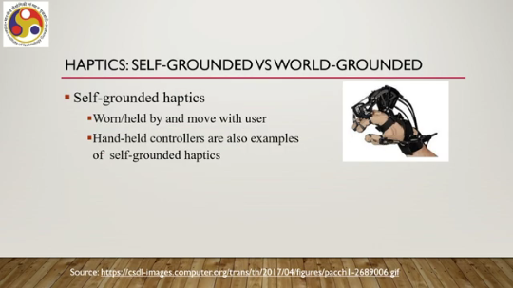
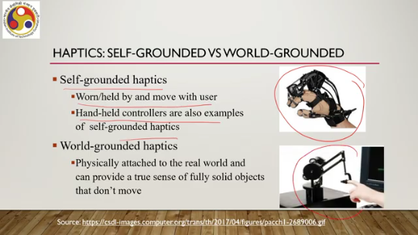
Another type of output devices are motion platforms. These are hardware devices that move the entire body resulting in a sense of physical motion and gravity. It conveys a sense of orientation, vibration, acceleration, and jerks. However, use of such platforms may result in motion sickness. which can be reduced by decreasing conflict between visual motion and the perceived motion in the real world.
So, such motion platforms can be of two types: active motion platform. These are controlled by computer simulation as shown here. So, computer controls the platform whereas, there can be passive motion platform which are controlled by the user; there is no direct computer control here. Passive platforms are likely to result in less motion sickness as compared to active platforms.
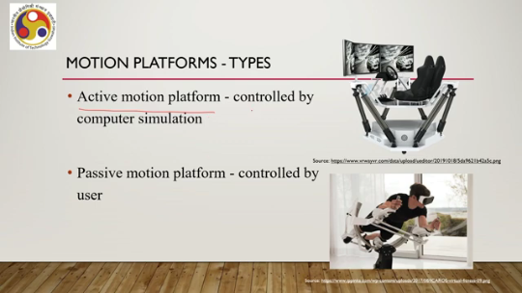
Also, there can be treadmills, another type of output device. It provides a sense that one is walking or running while actually staying in one place by providing different sorts of input to the feet or legs. We can have omnidirectional treadmills; these are quite common in virtual reality systems which can be of two types: active, that means it is controlled by a computer. So, computer-controlled mechanically moving parts are there which give us a sensation of walking or moving whereas there can be passive also, like motion platforms; it contains no computer
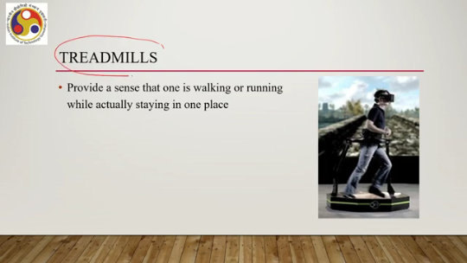
controlled mechanically moving parts. So, user has to control it himself or herself. So, with that we have come to the end of this lecture. Let us quickly summarize what we have learned. So, we have talked about different hardware devices used to generate VR experiences.
which included broadly three categories of devices: input, computer, and output. Input we have seen can be handheld input or non-handheld input, whereas output can be visual, auditory, touch or haptics, motion platforms, or proprioceptive forces. In our next lecture, we will cover the hardware that is used for AR experience, augmented reality experience. I hope you have understood the concepts; you have got an overview of the overall hardware that is used as part of the VR system, even the overall idea of a VR system as such.
So, I have used a few references to make this content. These are listed here. If you are interested, you can go through the references for more details. So thank you. Looking forward to meeting you in the next lecture.
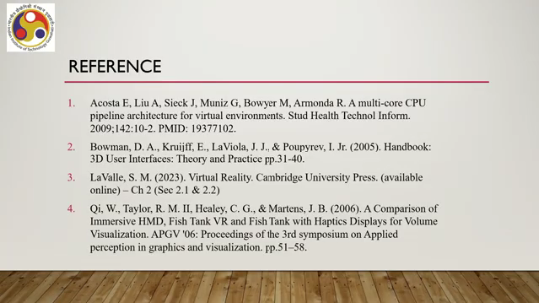
Happy learning.

